Advanced Algebra 2 Name: ______________
Notes 3.4: Solving 3X3 Systems of Equations: MATRICES
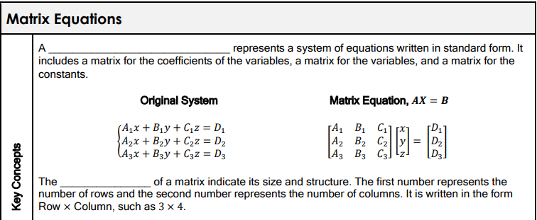

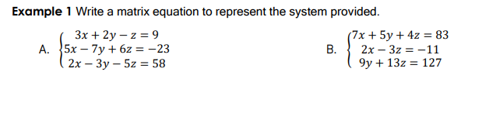

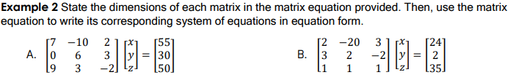

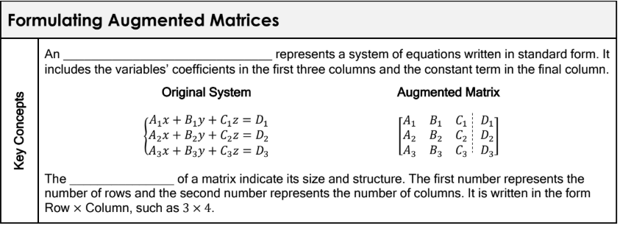

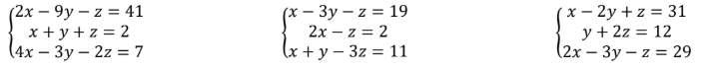
Example 3 Rewrite the system of equations as an augmented matrix. Then, state its dimensions.

Example 4 Write an augmented matrix to represent each system of equations, then solve.
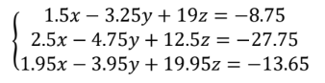
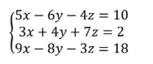

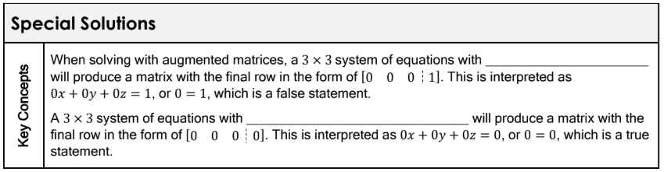

Example 5 Write an augmented matrix to represent the system, then solve.
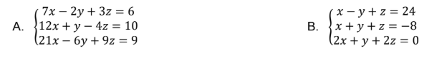

Calculator Directions for solving Matrices

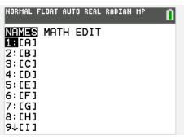
1. Push buttons: 2nd, $x^{-1}$(matrix)

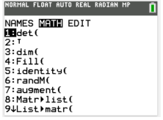
2. Arrow over one space to the right (math)

3. Push buttons: alpha, apps
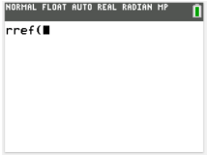
This will appear on screen:

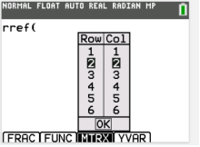
4. Push buttons: alpha, zoom

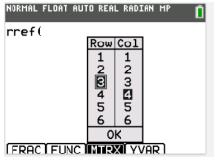
5. Choose rows and columns by pushing “up” and “down” arrows, then push Enter for each

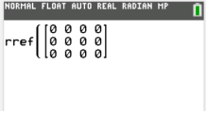
6. Arrow down to “ok” and push Enter

7. Enter values and navigate to the right

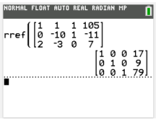
8. After all values are entered, push Enter and it will give you the answer

9. If you don’t have a diagonal of ones from upper left to lower right, the solution may be infinite or none.

